Supporting Information

¹⁸F-Glutathione Conjugate as a PET Tracer for Imaging Tumors that Overexpress L-PGDS Enzyme
Ho-Lien Huang,^{a,†} Ying-Cheng Huang,^{b,†} Wei-Yuan Lee,ª Chun-Nan Yeh,^{c} Kun-Ju Lin,^{d} and Chung-Shan Yu^{a,e*}
ªDepartment of Biomedical Engineering and Environmental Sciences, National Tsinghua University, Hsinchu 300, Taiwan.
^{b}Department of Neurosurgery, Chang-Gung memorial Hospital at Linkou, Chang Gung University, Taiwan.
^{c}Department of Surgery, Chang-Gung memorial Hospital at Linkou, Chang Gung University, Taiwan.
^{d}Department of Nuclear Medicine, Chang Gung Memorial Hospital at Linkou, Chang Gung University, Taiwan.
^{e}Institute of Nuclear Engineering and Sciences, National Tsinghua University, Taiwan.
†These authors contributed equally to this study.

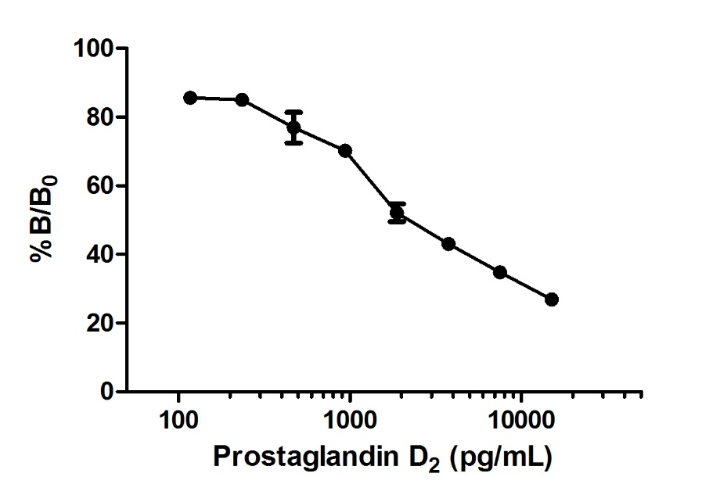
Figure S1. Calibration curve of the activity detected vs. PGD2 as the standard at various concentration.
The procedure for the experiment was outlined in Table S1 and S2.

Table S1. Protocols for formation of PGD2
Entry
stage | control |  | initial | inhibitor 1  (uridine) | inhibitor 2  (AT-56) | inhibitor 3  (FBuEA-GS)
1 | 470 uL reaction buffer |  | 460 uL reaction buffer | 450 uL reaction buffer | 450 uL reaction buffer | 450 uL reaction buffer
2 | 20 uL dithiothreitol (DTT)
3 | - |  | 10 uL L-PGDs
4 | - |  | - | 10 uL uridine | 10 uL AT-56 | 10 uL FBuEA-GS
5 | 10 uL PGH₂
6 | Shake for 1 min
6 | Add HCl (1 M, 50 uL)
7 | 10 uL FeCl₂
8 | Dilution (10000 fold) using EIA buffer | Dilute to 2000 fold using EIA buffer
EIA: enzymatic immuno assay

Table S2. Protocols for enzymatic immunological assay
Entry
stage | control | initial | inhibitor 1 (uridine) | inhibitor 2 (FBuEA-GS) | inhibitor 3 (AT-56)
1 | 50 uL from part A | 50 uL from part A | 50 uL from part A | 50 uL from part A | 50 uL from part A
2 | 50 uL tracer | 50 uL tracer | 50 uL tracer | 50 uL tracer | 50 uL tracer
3 | 50 uL antibody | 50 uL antibody | 50 uL antibody | 50 uL antibody | 50 uL antibody
4 | Sealed with parafilm and wait for 2 hr
5 | Wash with buffer (150 uL) for 5 times
6 | 200 uL Ellman’s reagent
7 | Sealed with parafilm under dark for 1hr
8 | Measure the absorbance at λ = 410 nm
tracer: acetylcholinesterase linked PGD2, antibody: specific to recognition of PGD2, Ellman’s reagent: 5,5’-dithiobis-(2-nitrobenzoic acid)

Table S3. Enzymes used for radioactive ligand binding assay
Enzymes used | Stock (uints/ volume) | Mixing condition | Adjusted concentration
PGES for both microsomal and human recombinant | 500 units/200 μL | PGES (150 μL, 375 units) and [¹⁸F]FBuEA-GS 3 (20 μL) | 2.2  units/μL
PGDS (lipocalin-type; mouse recombinant) | 250 μg / 200 μL | PGDS (150 μL, 0.4 units) and [¹⁸F]FBuEA-GS 3 (20 μL) | 2.4×10⁻³  units/μL
PGDS (lipocalin-type; rat recombinant) | 250 μg / 200 μL | PGDS (150 μL, 0.4 units) and [¹⁸F]FBuEA-GS 3 (20 μL) | 2.4×10⁻³  units/μL
PGDS (lipocalin-type; human recombinant) | 250 μg / 200 μL | PGDS (150 μL, 0.4 units) and [¹⁸F]FBuEA-GS 3 (20 μL) | 2.4×10⁻³  units/μL
COX-1 | 5000 units / 200 μL | COX-1 (100 μL, 250 units) and [¹⁸F]FBuEA-GS 3 (20 μL) | 20  units/μL
COX-2 | 5000 units / 600 μL | COX-2 (300 μL, 2500 units) and [¹⁸F]FBuEA-GS 3 (20 μL) | 7.8  units/μL
GST-α | 0.05 units/  (10 μL) | GST-α (5 μL, 0.025 units), [¹⁸F]FBuEA-GS 3 (10 μL) and phosphate pH = 7.3 (20 μL) | 7×10⁻⁴  units/μL
GST-π | 0.0325 units/  (5 μL) | GST-π (2.5 μL, 0.01625 units), [¹⁸F]FBuEA-GS 3 (10 μL) and phosphate pH = 7.3 (20 μL) | 5×10⁻⁴ units/μL

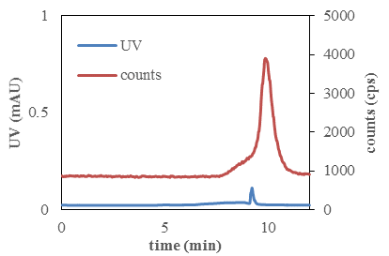(a) 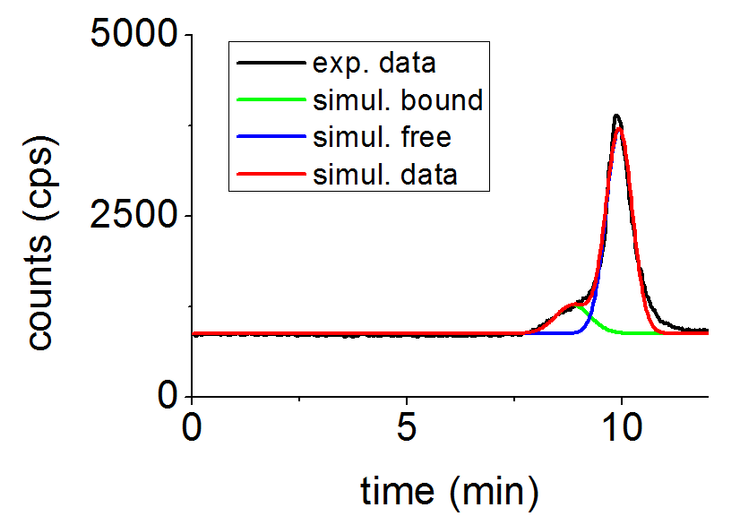(a’)
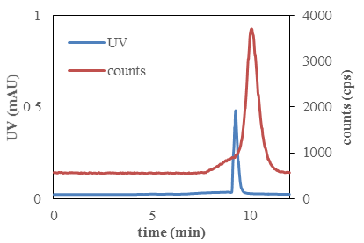(b) 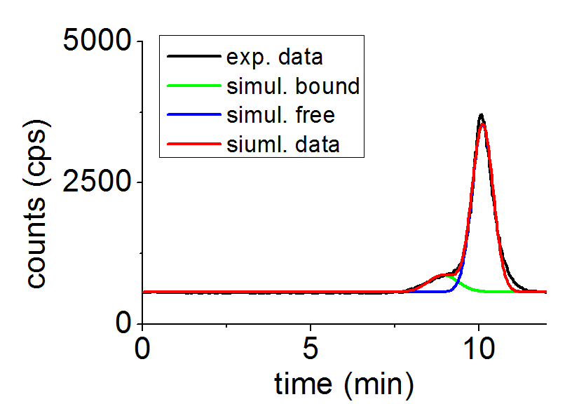(b’)
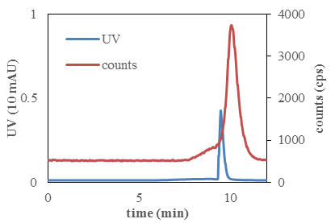(c) 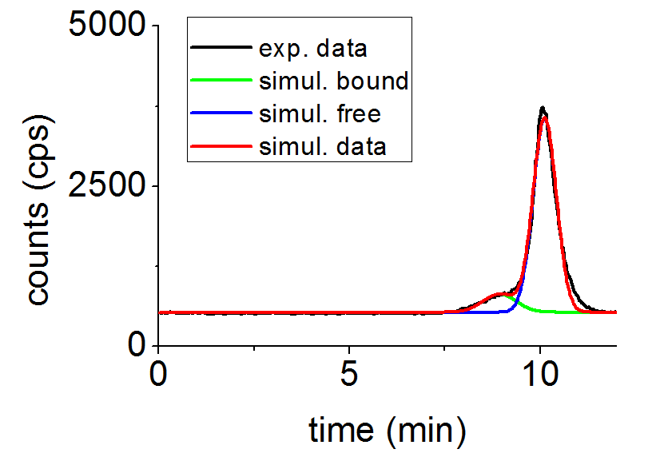(c’)
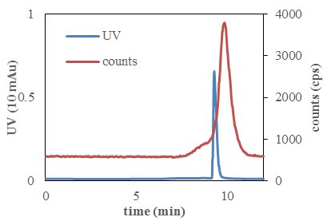(d) 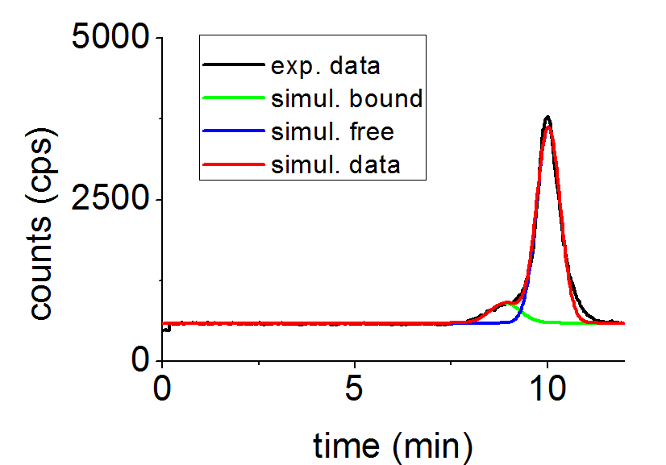(d’)
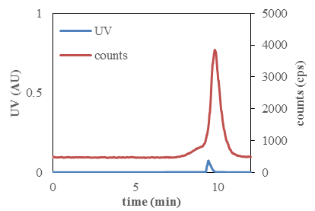(e) 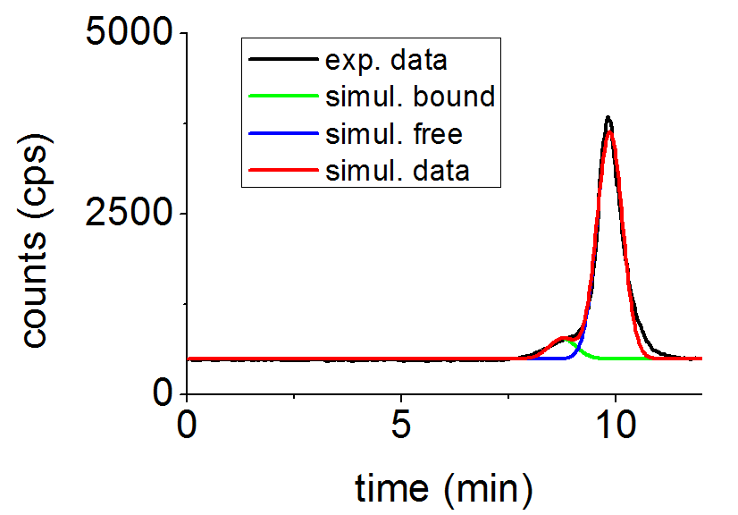(e’)
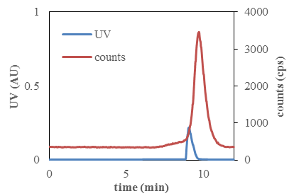(f) 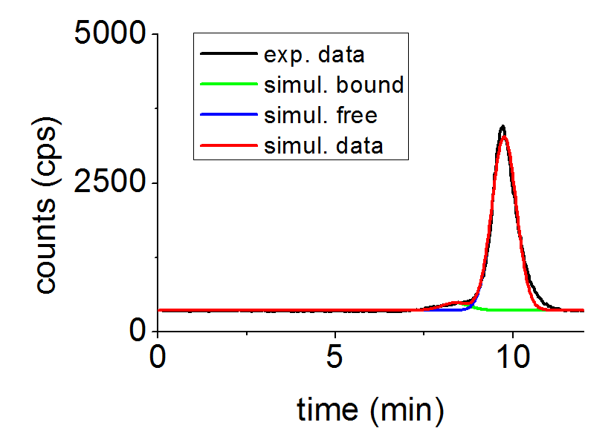(f’)
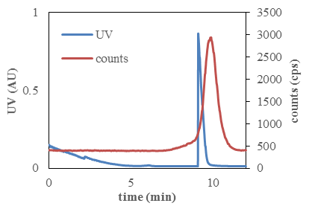(g) 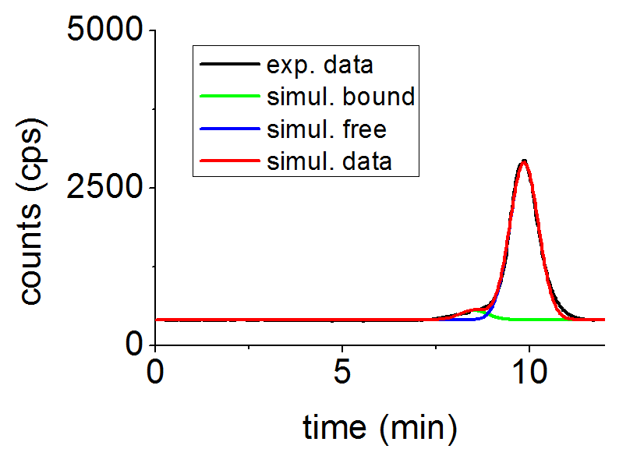(g’)
Figure S2. HPLC chromatogram of the binding analysis of [¹⁸F]FBuEA-GS 3 to L-PGDS. Nonradioactive FBuEA-GS 3 of (a) 0 μM, (b) 1 μM, (c) 7.5 μM, (d) 20 μM, (e) 150 μM, (f) 400 μM and (g) 1200 μM were used for the version of 5-sec. equilibrium. AU = arbitrary unit; mAU = 10⁻³×arbiturary unit. (a’)~(g’) are chromatograms resolved from the radioactivity signals of (a)~(g) using Origin software.

Table S4. Tabulation for the response of the UV absorption on the concentration of FBuEA-GS 3 of each HPLC chromatogram in Fig. S2
 | FBuEA-GS (μM)
 | 0 | 1 | 7.5 | 20 | 150 | 400 | 1200
UV integral  (AU) | 0.00145 | 0.00864 | 0.07787 | 0.18391 | 1.28835 | 4.71801 | 14.8279
AU: arbitrary unit

Figure S3. Illustration of the reponse of the UV absorption on the concentration of FBuEA-GS 3 in each HPLC chromatogram of Fig. S2.
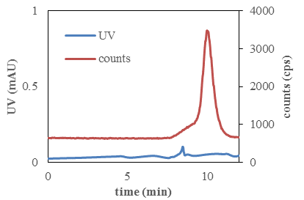 (a)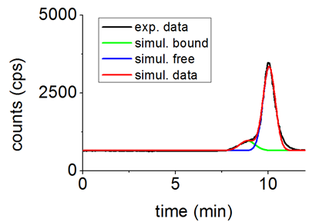(a’)
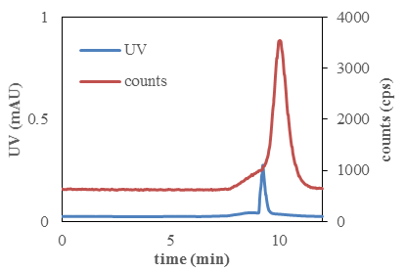 (b)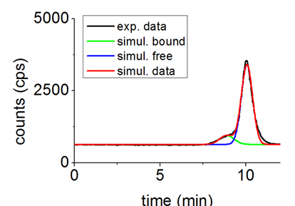(b’)
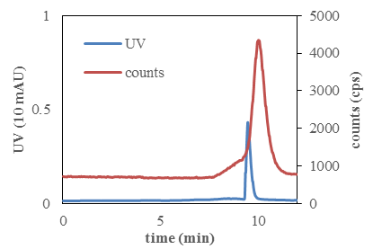 (c)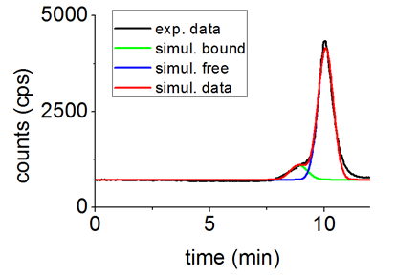(c’)
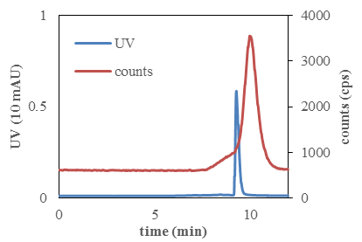 (d)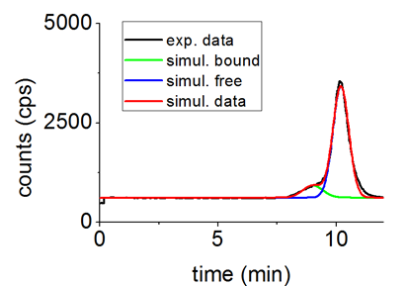(d’)
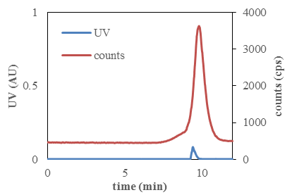 (e)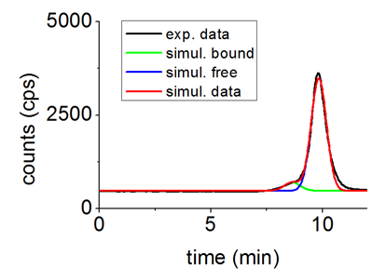(e’)
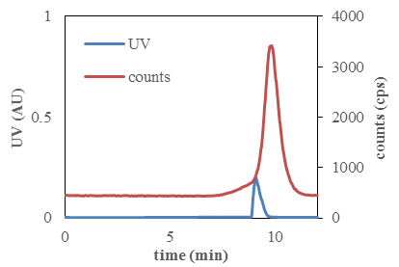 (f)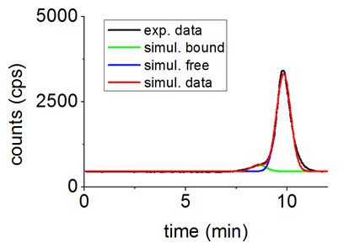(f’)
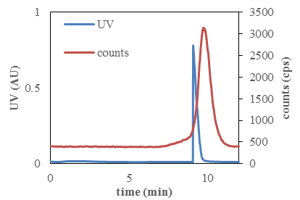 (g)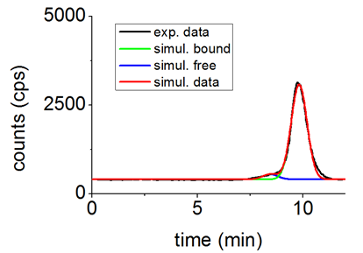(g’)
Figure S4. HPLC chromatogram of the binding analysis of [¹⁸F]FBuEA-GS 3 to L-PGDS. Nonradioactive FBuEA-GS 3 of (a) 0 μM, (b) 1 μM, (c) 7.5 μM, (d) 20 μM, (e) 150 μM, (f) 400 μM and (g) 1200 μM were used for the version of 10-min. equilibrium. AU = arbitrary unit; mAU = 10⁻³×arbiturary unit. (a’)~(g’) are chromatograms resolved from the radioactivity signals of (a)~(g) using Origin software.

Table S5. Tabulation for the response of the UV absorption on the concentration of FBuEA-GS 3 of each HPLC chromatogram in Fig. S4.
 | [¹⁸F]FBuEA-GS (μM)
 | 0 | 1 | 7.5 | 20 | 150 | 400 | 1200
UV peak  (AU) | 0.00143 | 0.00631 | 0.08263 | 0.16747 | 1.47014 | 4.99203 | 13.3452
AU: arbitrary unit

Figure S5. Illustration of the reponse of the UV absorption on the concentration of FBuEA-GS 3 of each HPLC chromatogram in Fig. S4.
Table S6. Tabulation for the integrals of the peaks corresponding to the bounded fom and free form in the HPLC chromatogram of [¹⁸F]FBuEA-GS 3 with L-PGDS.
Group A (5 sec. equilibrium)
Concentration of FBuEA-GS 3 added (μM) | integral of the bonded form | integral of the free form | sum of the two forms
0 | 1001.12 | 5428.64 | 6429.756725
1 | 836.8599 | 5804.340725 | 6641.20065
7.5 | 784.2733 | 5815.044725 | 6599.318
20 | 762.9938 | 5834.950925 | 6597.944675
150 | 568.2692 | 5872.867825 | 6441.137025
400 | 295.9052 | 6282.7765 | 6578.681725
1200 | 360.0933 | 5985.3802 | 6345.473475

Group B (10 min. equilibrium)
Concentration of FBuEA-GS 3 added (μM) | integral of the bonded form | integral of the free form | sum of the two forms
0 | 833.1892 | 5554.864975 | 6388.054175
1 | 844.3629 | 5650.7216 | 6495.0845
7.5 | 1016.404 | 6927.162625 | 7943.56635
20 | 834.9226 | 5915.824125 | 6750.7467
150 | 515.8714 | 6476.76715 | 6992.6385
400 | 442.4984 | 6240.6991 | 6683.197475
1200 | 334.4166 | 6281.74525 | 6616.161825

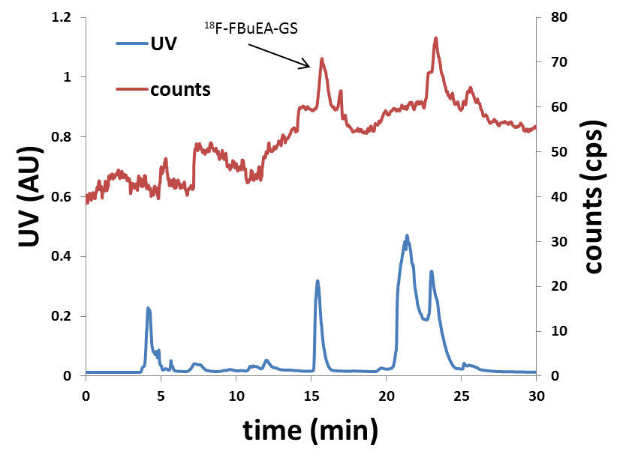(a)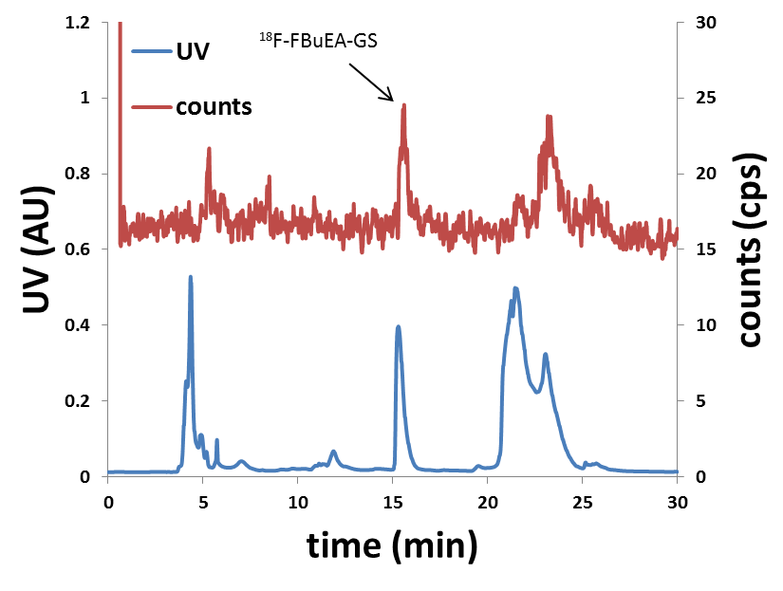(b)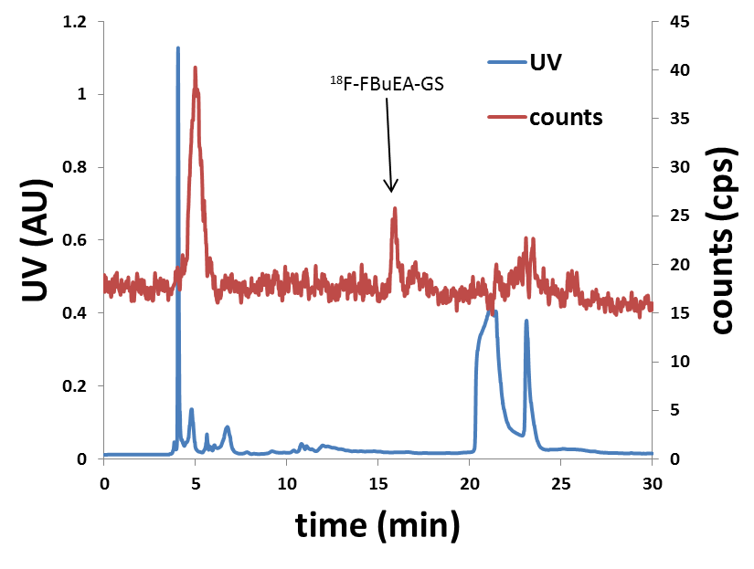(c)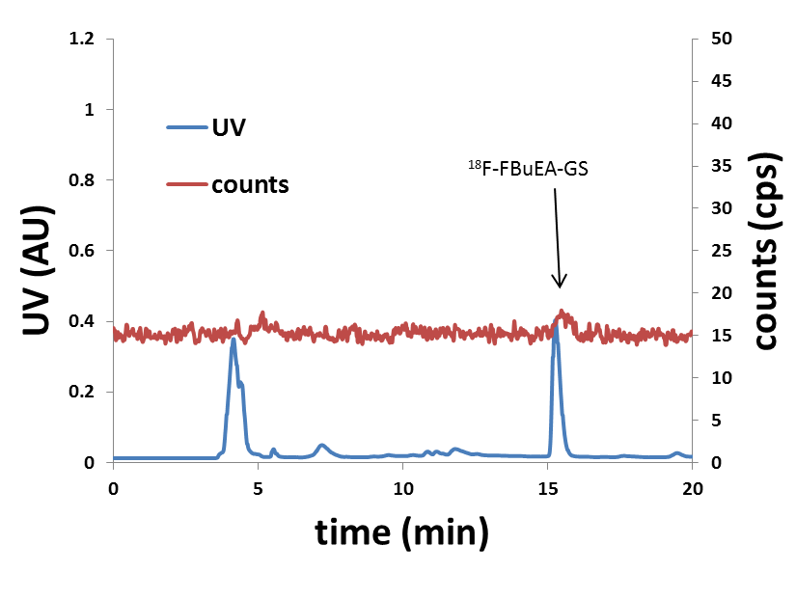(d)
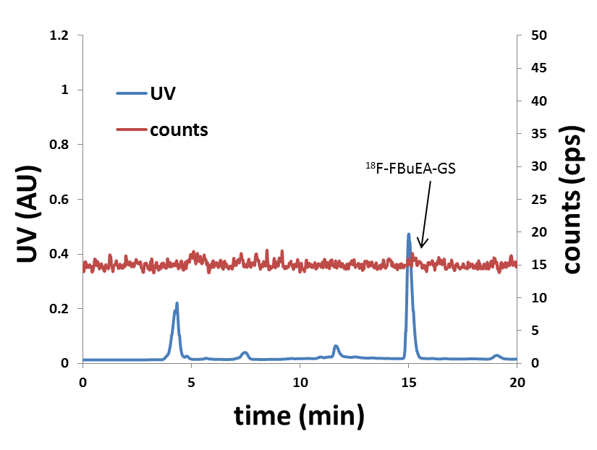(e)
Figure S6. RP-HPLC analysis of the radiometabolites from various blood samples at (a) 15 min, (b) 30 min, (c) 60 min, (d) 90 min and (e) 120 min post injection.

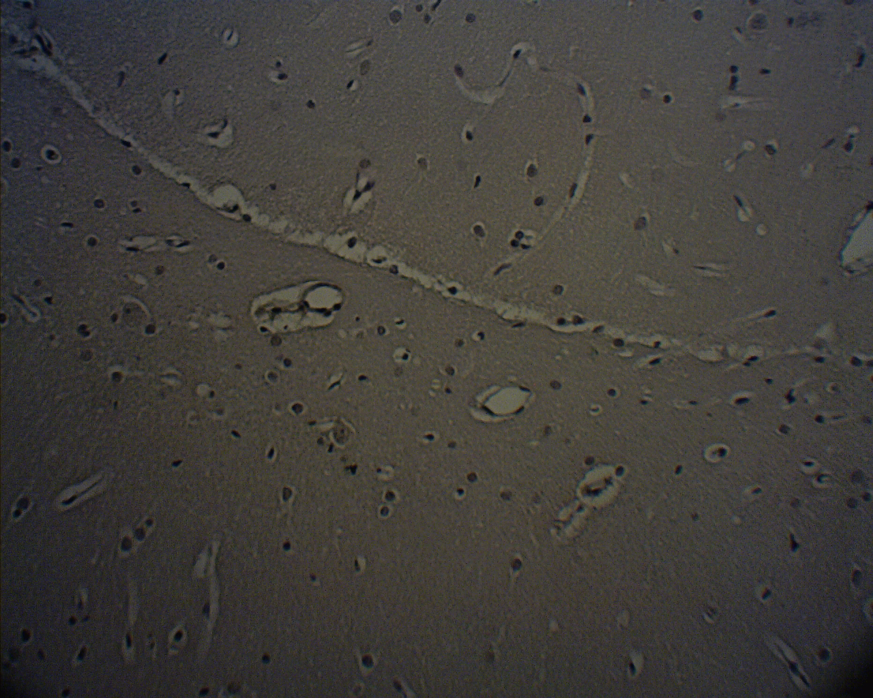
- COX-1 staining of normal brain tissue

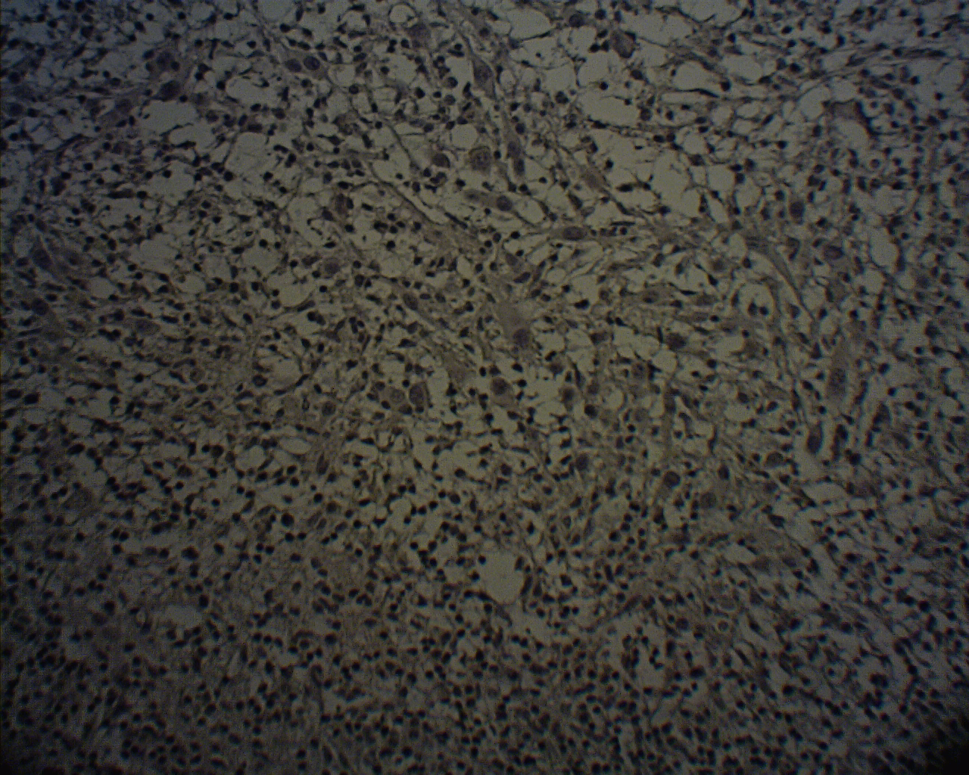
(B) COX1 staining- tumor center

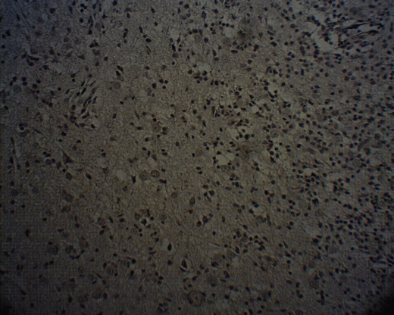
(C) COX2 staining- tumor/brain margin

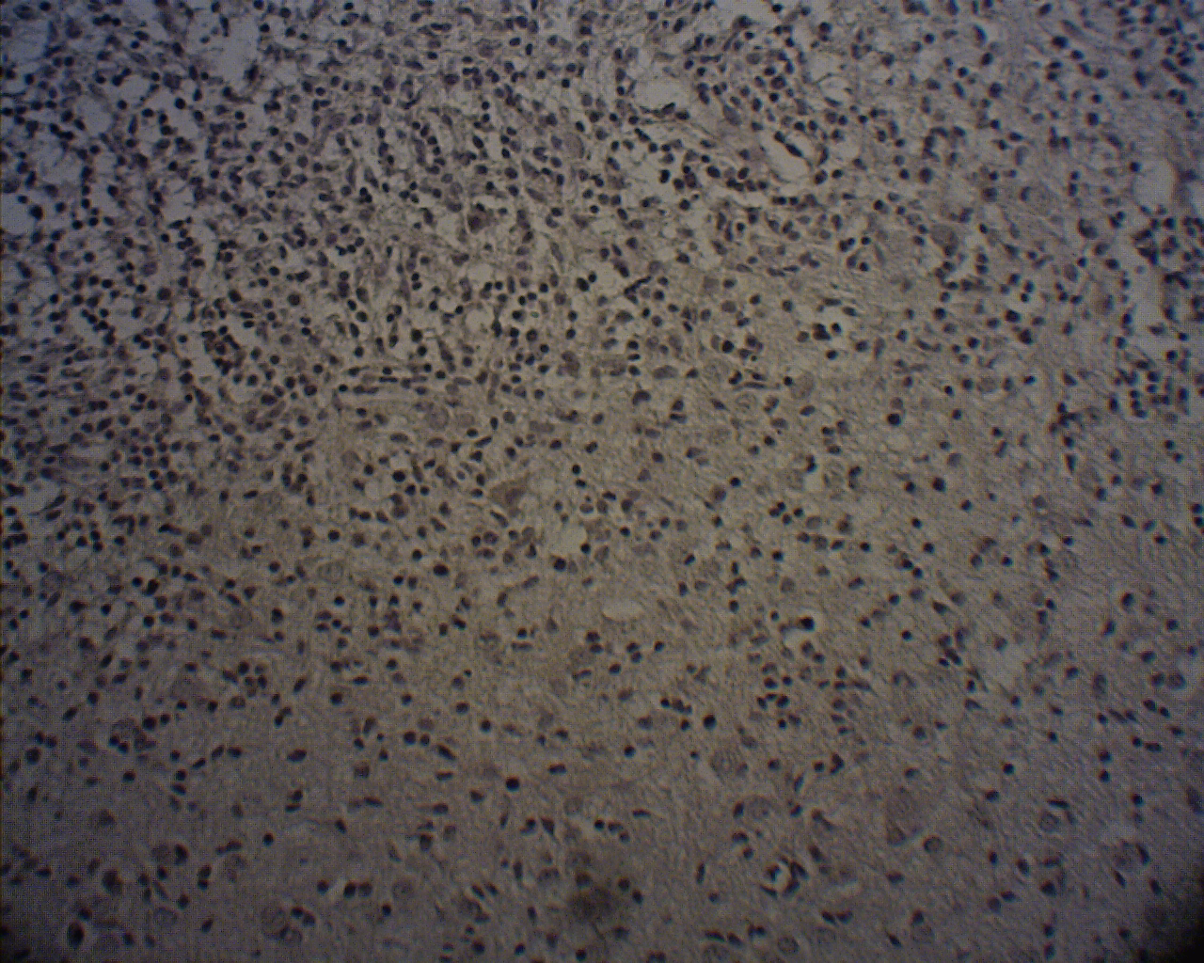
- L-PGDS staining- tumor/brain-100x
Figure S7. Immunohistological stainings for COXs and L-PGDS enzymes.
- COX-1 staining of normal brain tissue, (b) COX1 staining- tumor center, (c) COX2 staining- tumor/brain margin, (d) L-PGDS staining- tumor/brain-100x

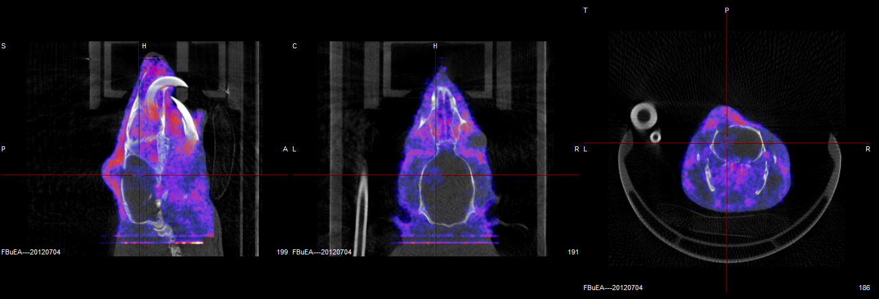
Figure S8. Fused CT-PET images of a C6-glioma rat for confirmation of the tumor implantation using the second PET scanner (nanoPET/CT, MEDISO Inc).
From left to right: sagittal image, coronal image and transverse image. Injection dose: 1.085 mCi/0.2 mL. Images were taken from the mean of 0-60 min.

