小組成員 | 學號 _____________________ 姓名_____________________  學號 _____________________ 姓名_____________________  學號 _____________________ 姓名_____________________  學號 _____________________ 姓名_____________________  學號 _____________________ 姓名_____________________

Section I. Multiple Choice Questions
1. Scarcity refers to the situation in which
A. unlimited wants exceed limited resources.
B. unlimited resources exceed limited wants.
C. a country's population is larger than its resource base.
D. a nation's poverty level increases faster than its population.

2. What is an economic model?
A. It is a description of an economic issue that includes all possible related information.
B. It is a description of an economic issue based on official government information.
C. It is a detailed version of some aspect of economic life used to analyze an economic issue.
D. It is a simplified version of some aspect of economic life used to analyze an economic issue.

3. Your roommate, Serafina, a psychology major, said, "The problem with economics is that it assumes that consumers and firms always make the correct decision. But we know that everyone's human, and we all make mistakes." Do you agree with her comment?
A. Yes, I agree with her. One cannot make predictions about economic behavior because in reality people make incorrect choices in many situations.
B. I disagree with her. Economics does not study correct or incorrect behaviors but rather it assumes that economic agents behave rationally, meaning they make the best decisions given their knowledge of the costs and benefits.
C. Yes, I agree with her. Economic theory should allow for irrational behavior so that we can have more reliable predictions.
D. I disagree with her. If we cannot assume that decisions are correct, then we will not be able to examine the moral implications of these decisions.

4. In the first six months of 2003, branches of Commerce Bank in New York City were robbed 14 times. The New York City Police recommended steps the bank could take to deter robberies, including the installation of plastic barriers called "bandit barriers." The police were surprised the bank did not take their advice. According to a deputy commissioner of police, "Commerce does very little of what we recommend. They've told our detectives they have no interest in ever putting in the barriers."
It would seem that Commerce bank would have a strong incentive to install "bandit barriers" to deter robberies. Why wouldn't they do it?
A. The banks would rather delay installation of any theft deterring equipment in anticipation of new lower cost innovations in the security devices market.
B. The banks must have weighed the cost of installing bandit barriers against the benefits and decided that they have "no interest in ever putting in the barriers".
C. The banks are concerned that "bandit barriers" would send the wrong message to customers -- that the bank is unsafe.
D. The banks probably resent any interference from the police department.

5. An office supply store sells a ream of printer paper at a fixed price of $4.50. Which of the following is a term used by economists to describe the money received from the sale of an additional ream of paper?
A. marginal revenue
B. gross earnings
C. pure profit
D. marginal costs
E. net benefit

6. Which of the following statements about positive economic analysis is true ?
A. Positive analysis uses an economic model to estimate the costs and benefits of different course of actions.
B. There is much less disagreement among economists over normative economic analysis than over positive economic analysis.
C. There is much more disagreement among economists over positive economic analysis than over normative economic analysis.
D. Unlike positive economic analysis, normative economic analysis can be tested.

7. Which of the following contributes to the efficiency of markets?
A. Governments play an active role in the day-to-day operations of markets.
B. Markets are able to bring about an equitable distribution of goods and services.
C. Markets promote equal standards of living.
D. Markets promote competition and voluntary exchange.

8. Refer to Figure 1 shown below. Which of the following statements is true?
A. The slope of the tangent at E is positive and the slope of the tangent at F is negative.
B. The slope of the tangent at E is negative and the slope of the tangent at F is positive.
C. The slope of the tangent at E and the slope of the tangent at F are negative.
D. The slope of the tangent at E and the slope of the tangent at F are positive.
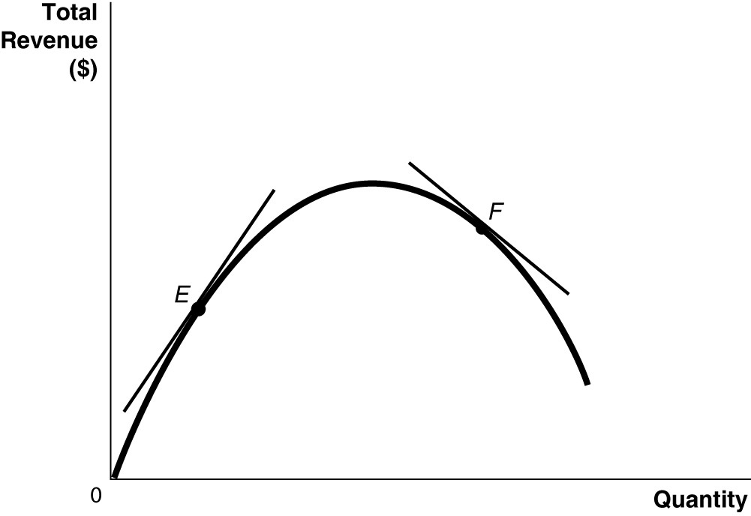
Figure 1

9. BMW recently decided to build a manufacturing plant in Shenyang, China. At this plant, BMW is able to take advantage of paying lower wages to its Chinese workers than it pays its German workers, but it also sacrifices the high levels of technical training possessed by its German workers. In deciding to open the Shenyang plant, BMW
A. faced no trade-offs because employing lower-wage workers increased efficiency.
B. faced a trade-off between higher cost and lower precision.
C. adopted a negative technological change because it replaced high-skilled workers with low-skilled workers.
D. eroded some of its competitiveness in the luxury car market because of its decreased cost of production.
10. Refer to Figure 2. Sergio Vignetto raises cattle and llamas on his land. A portion of his land is more suitable for raising cattle, and the other portion is better suited for raising llamas. Which of the graphs in Figure 2 represent his production possibilities frontier?
A. Graph A
B. Graph B
C. Graph C
D. either Graph A or Graph C
E. either Graph B or Graph C

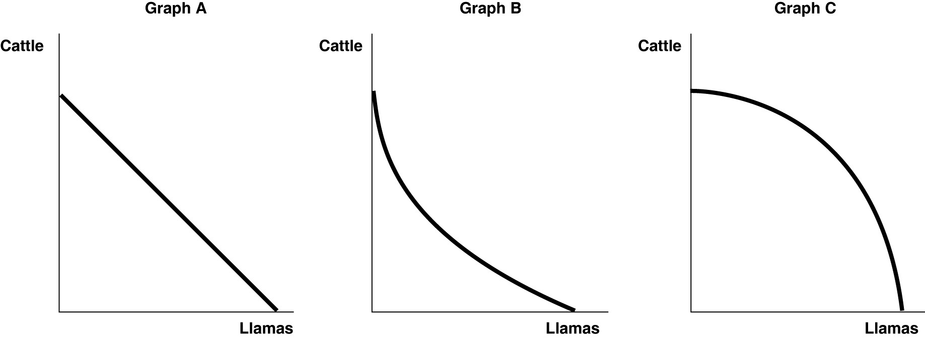
Figure 2

11. Suppose your expenses for this term are as follows: tuition: $12,000, room and board: $6,500, books and other educational supplies: $1,500. Further, during the term, you can only work part-time and earn $3,500 instead of your full-time salary of $14,000. What is the opportunity cost of going to college this term, assuming that your room and board expenses would be the same even if you did not go to college?
A. $13,500
B. $20,000
C. $24,000
D. $30,500

12. Specializing in the production of a good or service in which one has a comparative advantage enables a country to do all of the following except
A. engage in mutually beneficial trade with other nations.
B. increase the variety of products that it can consume with no increase in resources.
C. consume a combination of goods that lies outside its own production possibilities frontier.
D. produce a combination of goods that lies outside its own production possibilities frontier.
13. The ________ demonstrates the roles played by households and firms in the market system.
A. production possibilities frontier
B. circular flow model
C. theory of comparative advantage
D. business cycle

14. Consider the following items:
a.the novel "The DaVinci Code" by Dan Brown
b.the "The Spirited Shipper", an innovative wine shipping box
c.a Swiss chef's award-winning recipe
d.an original fabric design, for example, the fabric used for "Coach" bags and luggage

Which of the items listed is an example of intellectual property?
A. a and b only
B. a, b, and c
C. a and d only
D. all of the items listed

15. The Great Depression of the 1930s with a large number of workers and factories unemployed would be represented in a production possibilities frontier graph by
A. a point inside the frontier.
B. a point outside the frontier.
C. a point on the frontier.
D. an intercept on either the vertical or the horizontal axis.

Section II. Essay Questions
- The country of Estonia has attempted to increase its birthrate by making payments to women who have babies. According to an article in the Wall Street Journal, “Some demographers argue that paying people to have a baby simply makes them have one earlier; it doesn’t necessarily make them have more.”
Reread the description of Estonia’s programs shown on page 5 in chapter one.
- Could the program be changed in ways that might make it more likely that Estonian women will have more children rather than simply changing the timing of when they have children?
- What information would we need to have to resolve the question of whether Estonian women are responding to the government’s incentives by having more children or simply by having them earlier?

- Using the same amount of resources, the United States and Canada can both produce lumberjack shirts and lumberjack boots, as shown in the following production possibilities frontiers.

United States
Canada
Quantity of shirts made
Quantity of shirts made

12

6

3
3

0
4
3
0
6
3
Quantity of boots made
Quantity of boots made

- Who has a comparative advantage in producing lumberjack boots? Who has a comparative advantage in producing lumberjack shirts? Explain your reasoning.
- Does either country have an absolute advantage in producing both goods? Explain.
- Suppose that both countries are currently producing three pairs of boots and three shirts. Show that both can be better off if they each specialize in producing one good and then engage in trade.

