小組成員 | 學號 _____________________ 姓名_____________________  學號 _____________________ 姓名_____________________  學號 _____________________ 姓名_____________________  學號 _____________________ 姓名_____________________  學號 _____________________ 姓名_____________________

Section I. Multiple Choice Questions

1. ________ shows that if all resources are fully and efficiently utilized, more of one good can be produced only by producing less of another good.
A. Comparative advantage
B. Absolute advantage.
C. The mixed market system
D. The production possibilities frontier model

2. A student comments to his roommate that the only way he will be able to pass his final exams is to not sleep for the next three days. This statement suggests that
A. students are more concerned about good grades than good health.
B. society should value sleep more highly than good grades.
C. there is a trade-off between studying and sleep.
D. society should value good grades more highly than sleep because students can catch up on their sleep once final exams are over.

3. If the price of a good or service rises, households have to choose whether to buy less of that good or service or spend less on other goods and services. Studies have shown that when the price of health care rises,
A. people cut back on their spending of medical services.
B. people continue to consume the same amount of medical services and reduce spending on other goods and services, because medical services are viewed as a necessity.
C. people consume more medical services because these services are viewed as being more valuable, and they significantly reduce spending on other goods and services.
D. there is no correlation between the rising prices of medical services and the quantity of these services consumed.

4. Izzy Amador is a highly talented tattoo artist. She has chosen to specialize in photography because of all of the following except
A. her tattoos are highly esteemed by tattoo lovers who are willing to pay very high prices.
B. for her, this is the most lucrative way to purchase the products that she wants to consume.
C. her opportunity cost of pursuing another career is very low.
D. she obviously has a comparative advantage in tattoo art.

5. Which of the following is not a flow in the circular flow model?
A. the flow of goods and services and the flow of resources to produce goods and services
B. the flow of profit and the flow of revenue
C. the flow of income earned by households and the flow of expenditures incurred by households
D. the flow of revenue received by producers and the flow of payments to resource owners

6. If you are considering buying either a can of Red Bull or a can of Monster Energy, and you choose Monster only because the price is lower, then you consider
A. Red Bull and Monster to be complements.
B. Red Bull and Monster to be substitutes.
C. Red Bull to be a normal good and Monster to be an inferior good.
D. Red Bull to be an inferior good and Monster to be a normal good.

Kona Coffee Price per lb. (dollars) | Luke's Quantity  Demanded (lb.) | Ravi's Quantity  Demanded (lb.) | Rest of Market  Quantity  Demanded (lb.) | Market Quantity  Demanded (lb.)
$10 | 3 | 0 | 23
8 | 9 | 3 | 32
6 | 14 | 7 | 68
5 | 18 | 12 | 85
4 | 22 | 18 | 110
Table 1

7. Refer to Table 1. The table above shows the demand schedules for Kona coffee of two individuals (Luke and Ravi) and the rest of the market. At a price of $6, the quantity demanded in the market would be
A. 36 lb.
B. 68 lb.
C. 89 lb.
D. 123 lb.

8. Refer to Table 1. The table above shows the demand schedules for Kona coffee of two individuals (Luke and Ravi) and the rest of the market. If the price of Kona coffee rises from $4 to $5, the market quantity demanded would
A. decrease by 35 lb.
B. increase by 115 lb.
C. increase by 35 lb.
D. decrease by 115 lb.

9. According to a recent study, "Stricter college alcohol policies, such as raising the price of alcohol, or banning alcohol on campus, decrease the number of students who use marijuana." On the basis of this information, how would you describe alcohol and marijuana?
A. The two goods are substitutes in consumption.
B. There is no relationship between the two goods.
C. The two goods are complements in consumption.
D. They are both luxury goods.

10. Last month, the Tecumseh Corporation supplied 400 units of three-ring binders at $6 per unit. This month, the company supplied the same quantity of binders at $4 per unit. Based on this evidence, Tecumseh has experienced
A. a decrease in supply.
B. an increase in supply.
C. an increase in the quantity supplied.
D. a decrease in the quantity supplied.
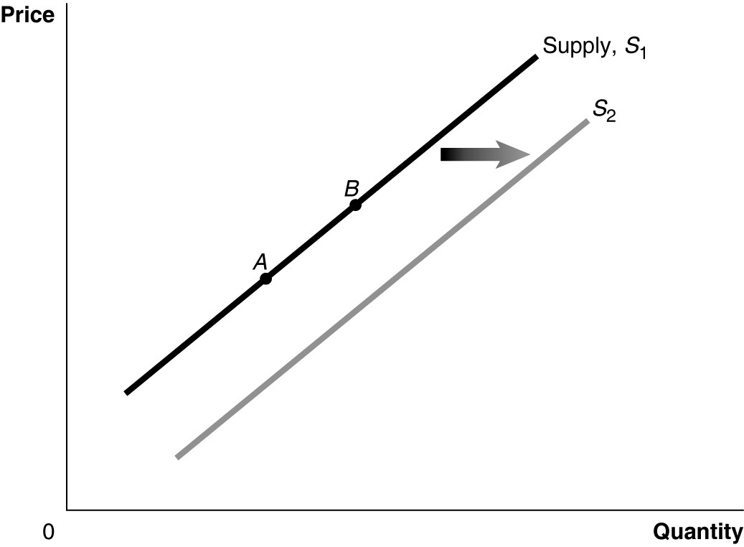
Figure 2

11. Refer to Figure 2. A technological advancement would be represented by a movement from
A. A to B.
B. B to A.
C. S₁ to S₂.
D. S₂ to S₁.

12. Refer to Figure 2. An increase in the expected future price of the product would be represented by a movement from
A. A to B.
B. B to A.
C. S₁ to S₂.
D. S₂ to S₁.

13. George Gnat subscribes to a monthly pest control service for his home. Last week the owner of the service informed George that he will have to raise his monthly service fee because of increases in the price of gasoline used by his workers on their service trips. How is the market for pest control services affected by this?
A. There is an increase in the supply of pest control services.
B. There is a decrease in the demand for pest control services.
C. There is a decrease in the quantity supplied of pest control services.
D. There is a decrease in the supply of pest control services.

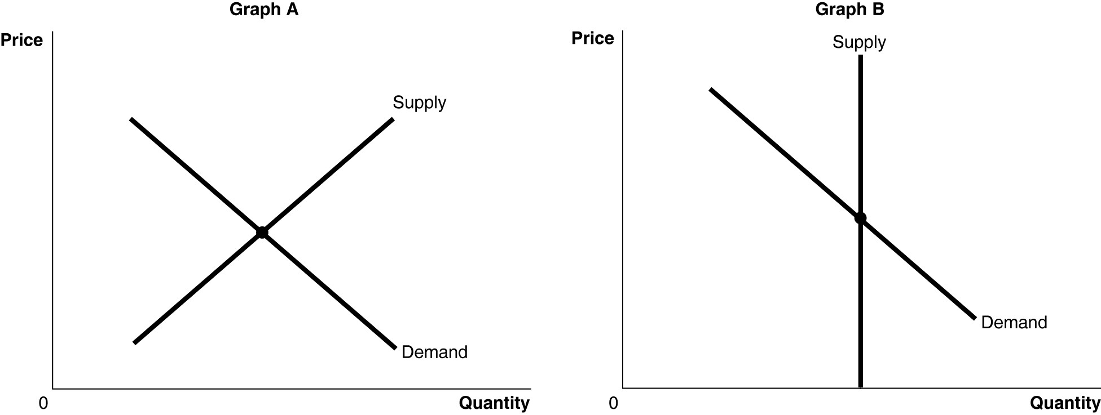
Figure 3

14. Refer to Figure 3. The figure above shows the supply and demand curves for two markets: the market for original Michelangelo sculptures and the market for Ray Ban sunglasses. Which graph most likely represents which market?
A. Graph B represents the market for original Michelangelo sculptures and Graph A represents the market for Ray Ban sunglasses.
B. Graph A represents the market for original Michelangelo sculptures and Graph B represents the market for Ray Ban sunglasses.
C. Graph A represents both the market for original Michelangelo sculptures and Ray Ban sunglasses.
D. Graph B represents both the market for original Michelangelo sculptures and Ray Ban sunglasses.

15. In recent years the cost of producing wines in the U.S. has increased largely due to rising rents for vineyards. At the same time, more and more Americans prefer wine over beer. Which of the following best explains the effect of these events in the wine market?
A. The supply curve has shifted to the left and the demand curve has shifted to the right. As a result there has been an increase in the equilibrium quantity and an uncertain effect on the equilibrium price.
B. Both the supply and demand curves have shifted to the right. As a result, there has been an increase in the equilibrium price and an uncertain effect on the equilibrium quantity.
C. Both the supply and demand curves have shifted to the right. As a result, there has been an increase in both the equilibrium price and the equilibrium quantity.
D. The supply curve has shifted to the left and the demand curve has shifted to the right. As a result, there has been an increase in the equilibrium price and an uncertain effect on the equilibrium quantity.
Section II. Essay Questions
- Identify whether each of the following transactions will take place in the factor market or in the product market and whether households or firms are supplying the good or service or demanding the good or service:
a. George buys a BMW X5 SUV.
b. BMW increases employment at its Spartanburg plant.
c. George works 20 hours per week at McDonald’s.
d. George sells land he owns to McDonald’s so it can build a new restaurant.

- A student was asked to draw a demand and supply graph to illustrate the effect on the laptop computer market of a fall in the price of computer hard drives, ceteris paribus. She drew the graph below and explained it as follows:
Hard drives are an input to laptop computers, so a fall in the price of hard drives will cause the supply curve for personal computers to shift to the right (from S₁ to S₂). Because this shift in the supply curve results in a lower price (P₂), consumers will want to buy more laptops, and the demand curve will shift to the right (from D₁ to D₂). We know that more laptops will be sold, but we can’t be sure whether the price of laptops will rise or fall. That depends on whether the supply curve or the demand curve has shifted farther to the right. I assume that the effect on supply is greater than the effect on demand, so I show the final equilibrium price (P₃) as being lower than the initial equilibrium price (P₁).
S₁
Price

S₂

P₁

P₃
P₂

D₁
D₂
Quantity

Explain whether you agree or disagree with the student’s analysis. Be careful to explain exactly what─if anything─you find wrong with her analysis.

- As oil prices rose during 2006, the demand for alternative fuels increased. Ethanol, one alternative fuel, is made from corn. According to an article in the Wall Street Journal, the price of tortillas, which are made from corn, also rose during 2006: “The price spike [in tortillas] is part of a ripple effect from the ethanol boom.”
a. Draw a demand and supply graph for the corn market and use it to show the effect on this market of an increase in the demand for ethanol. Be sure to indicate the equilibrium price and quantity before and after the increase in the demand for ethanol.
b. Draw a demand and supply graph for the tortilla market and use it to show the effect on this market of an increase in the price of corn. Once again, be sure to indicate the equilibrium price and quantity before and after the increase in the demand for ethanol.
c. During 2009, the demand for gasoline had fallen, lowering its price. The demand for ethanol had declined as well. Ethanol producers, though, were asking the Environmental Protection Agency (EPA) to raise the allowable amount of ethanol in gasoline blends from 10 percent to 15 percent. If the EPA were to agree to this proposal, what would be the likely effect on tortilla prices?

