組別 | 姓名與學號

Homework #1
Economics (I), 2012
Due day: 2012.10.17

Part I. Multiple Choices: 60% (5% each)

Please fill your answers in below blanks.
1 | 2 | 3 | 4 | 5 | 6 | 7 | 8 | 9 | 10 | 11 | 12 | 13 | 14 | 15

1) Which of the following statements is true about scarcity?
A) Scarcity refers to the situation in which unlimited wants exceed limited resources.
B) Scarcity is not a problem for the wealthy.
C) Scarcity is only a problem when a country has too large a population.
D) Scarcity arises when there is a wide disparity in income distribution.

2) Economists assume that individuals
A) behave in unpredictable ways.
B) will never take actions to help others.
C) prefer to live in a society that values fairness above all else.
D) are rational and respond to incentives.

3) The highest valued alternative that must be given up to engage in an activity is the definition of
A) economic equity.
B) marginal benefit.
C) opportunity cost.
D) marginal cost.

4) Allocative efficiency best explains ________, and productive efficiency best explains ________.
A) how something will be produced; when something will be produced
B) when something will be produced; why something will be produced
C) why something will be produced; what will be produced
D) what will be produced; how something will be produced
5) Which of the following statements about positive economic analysis is false?
A) Positive analysis uses an economic model to estimate the costs and benefits of different course of actions.
B) There is much more disagreement among economists over normative economic analysis than over positive economic analysis.
C) There is much more disagreement among economists over positive economic analysis than over normative economic analysis.
D) Unlike normative economic analysis, positive economic analysis can be tested.

6) Which of the following is a microeconomics question?
A) How much will be saved and how much will be produced in the entire economy?
B) What will the level of economic growth be in the entire economy?
C) What factors determine the price of carrots?
D) What determines the average price level and inflation?

7) The production possibilities frontier shows the ________ combinations of two products that may be produced in a particular time period with available resources.
A) minimum attainable
B) maximum attainable
C) only
D) equitable

8) The slope of a production possibilities frontier
A) has no economic relevance or meaning.
B) is always constant.
C) is always varying.
D) measures the opportunity cost of producing one more unit of a good.

Figure 2-4

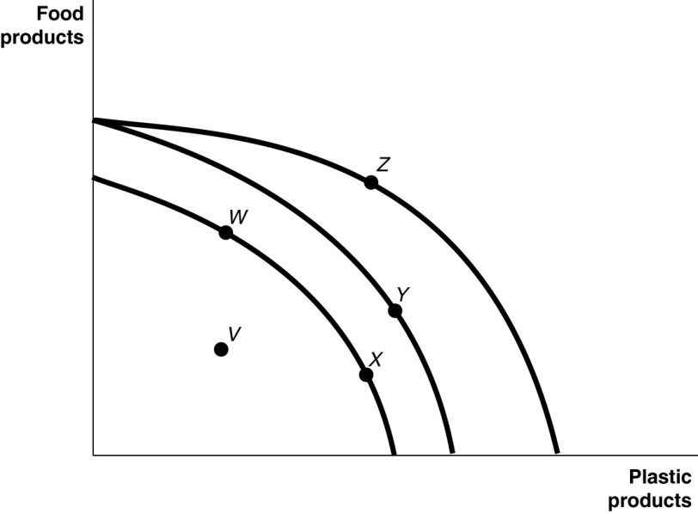
Figure 2-4 shows various points on three different production possibilities frontiers for a nation.
9) Refer to Figure 2-4. A movement from X to Y
A) could be due to a change in consumers' tastes and preferences.
B) could occur because of an influx of immigrant labor.
C) is the result of advancements in food production technology only, with no change in the technology for plastic production.
D) is the result of advancements in plastic production technology only, with no change in food production technology.

10) You have an absolute advantage whenever you
A) are better educated than someone else.
B) can produce more of something than others with the same resources.
C) prefer to do one particular activity.
D) can produce something at a lower opportunity cost than others.

Table 2-3

 | Serena | Haley
Bracelets | 8 | 9
Necklaces | 16 | 12

Table 2-3 shows the output per week of two jewelers, Serena and Haley. They can either devote their time to making bracelets or making necklaces.

11) Refer to Table 2-3. Which of the following statements is true?
A) Haley has an absolute advantage in making both products.
B) Serena has an absolute advantage in making both products.
C) Haley has an absolute advantage in making bracelets and Serena in making necklaces.
D) Haley has an absolute advantage in making necklaces and Serena in making bracelets.

12) Refer to Table 2-3. What is Serena's opportunity cost of making a necklace?
A) 2 necklaces
B) 1/2 of a bracelet
C) 1/2 of a necklace
D) 3/4 of a bracelet

13) Refer to Table 2-3. Which of the following statements is true?
A) Haley has a comparative advantage in making both products.
B) Serena has a comparative advantage in making both products.
C) Haley has a comparative advantage in making bracelets and Serena in making necklaces.
D) Haley has a comparative advantage in making necklaces and Serena in making bracelets.

14) Which of the following is an example of spending on goods and services in the circular flow model?
A) Belinda purchases a new computer for her tax-preparation business.
B) Javier buys 800 square feet of wood flooring for his vacation home.
C) Celeste buys fresh herbs at the farmers' market to use in her restaurant.
D) Timmy purchases a new examination table for use in his veterinary clinic.

15) The term "property rights" refers to
A) the physical possession of a house or any other property which the owner legally purchased.
B) the ability to exercise control over one's own resources within the confines of the law.
C) the government's right to appropriate land from wealthy land owners to redistribute to peasants.
D) the right of a business not to have its assets confiscated by the government in the event that the business is accused of committing fraud.
Part II. Problems: 40%

1) How do firms and households interact in markets?

2) Using the same amount of resources, the United States and Canada can both produce lumberjack shirts and lumberjack boots, as shown in the following production possibilities frontiers:
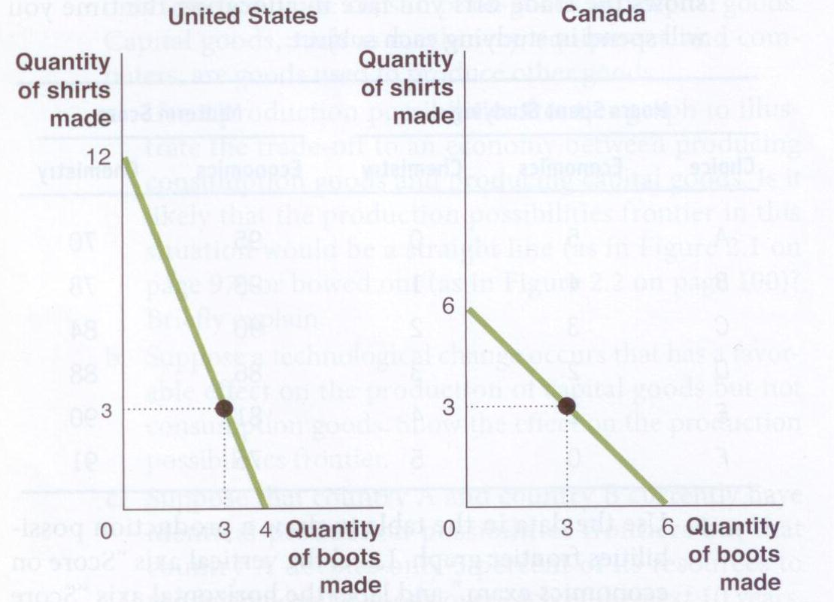
a. Who has a comparative advantage in producing lumberjack boots? Who has a comparative advantage in producing lumberjack shirts? Explain your reasoning.
b. Does either country have an absolute advantage in producing both goods? Explain.
c. Suppose that both countries are currently producing three pairs of boots and three shirts. Show that both can be better off if they each specialize in producing one good and then engage in trade.

