人力資源理論與應用
Theory and Application of Human Resources
ECON4203
Homework #1
March 2014
Due date: 4/9/2014
小組成員：
學號 | 姓名 | 學號 | 姓名 | 學號 | 姓名
學號 | 姓名 | 學號 | 姓名 | 學號 | 姓名

- Multiple Choices( 30 Points)
Please fill your answers in below blanks.
1 | 2 | 3 | 4 | 5 | 6 | 7 | 8 | 9 | 10
A | D | E | E | B | D | C | B | C | D

- Which of the following is not a leading actor in labor markets?
- Consumers
- Firms
- Workers
- Government
- Unions

- Suppose labor supply can be described as ES = 0.1w - 1,000 where w is yearly salary. How many workers are willing to work when the yearly salary is $20,000?
- 100
- 200
- 500
- 1,000
- 2,000

- Which of the following is not a property of standard indifference curves in a leisure-consumption model?
- Indifference curves tend to be downward sloping.an increase in the demand for oranges.
- Higher indifference curves (to the northeast) indicate higher levels of utility.
- Indifference curves tend to be convex to the origin.
- There is an indifference curve passing through every leisure-consumption bundle.
- Indifference curves intersect one another.

- What would a person do if the market wage is less than his or her reservation wage?
- The person will enter the labor market.
- The person will work as much as possible.
- The person will work more hours as the wage falls further.
- The person will be unemployed.
- The person will not participate in the labor force.

- What is the budget line for consumption (C) and leisure (L) if a person faces a constant wage of $10 per hour, there are 168 hours in the week to work, and she receives non-labor income of $220 per week?
- C = 1,900
- C + 10L = 1,900
- L = 10C + 220
- C - 10L = 1,460
- 10C - L = 1,460

- At what point should a firm stop hiring workers?
- When the wage per worker starts to increase.
- When the price of capital starts to decrease.
- When the firm's marginal gain from hiring an additional worker is zero.
- When the firm's marginal profit from hiring an additional worker equals the cost of hiring that worker.
- When the firm's value of marginal product equals zero.

- How does a profit-maximizing firm that is operating in a competitive labor market respond to an increase in the wage rate?
- The firm will demand less capital due to the substitution effect.
- The firm will demand more labor due to the substitution effect.
- The firm will produce less output due to the scale effect.
- The firm will demand more capital due to the scale effect.
- The firm will demand more labor due to the scale effect.

8. What is not true when thinking of the firm's objective as a cost-minimization problem rather than as a profit-maximization problem?
- The slope at any point on any isoquant reveals the marginal rate of technical substitution.
- The firm chooses labor and capital to minimize its costs.
- The firm chooses a particular level of output to produce.
- The price of the output good never enters the decision as to how much labor or capital to employ.
- The firm will choose labor and capital inputs so that the marginal productivity of labor relative to the marginal productivity of capital equals the price of labor relative to the price of capital.

9. What is an example of the scale effect?
- Workers choose to provide more hours of labor when the wage rate decreases.
- Hiring more labor as long as the marginal product of labor is positive.
- The firm expands output when production costs fall.
- The firm expands output when production costs increase.
- The firm hires more labor when the wage falls because labor has become relatively cheaper compared to the price of other factors of production.

10. Ally owns a shoe store. The market wage is $10 per hour, and the cost of capital is $2 per week for every $1,000 of capital borrowed. Consider the isocost line associated with spending $8,000 per week, and let the y-axis be the amount of capital borrowed in $1,000s. Which of the following is not true?
- If Ally borrows no capital, she can employ 800 hours of work.
- If Ally employs no workers, she can borrow $4 million of capital.
- If Ally employs 600 hours of work, she can borrow $1 million of capital.
- If Ally employs 400 hours of work, she can borrow $3 million of capital.
- The slope of the isocost line is -5.

- True and False (30 points)
Respond to each statement True, False or Uncertain and then justify your response. The justification of your response is the most important part of your answer.
- Labor demand is more elastic the greater the elasticity of substitution between labor and capital because firms always have the option of substituting capital for labor.
False
It is because a firm is less willing to pay higher labor costs if it is easy for the firm to substitute capital for labor.

- According to the income effect, an increase in the wage rate will lead the worker to work fewer hours if leisure is a normal good.
True
w↑, Income↑→ L↑, because L is normal good.
→ Labor supply
- Assuming consumption and leisure are normal goods, hours worked will fall when the wage increases if the income and substitution effect move in the same direction (i.e., if they are of the same sign)
False
if the income effect dominates the substitution effect
關鍵就在於不同方向的影響效果
w↑ $\left\{\begin{aligned}I.E. L↑,H↓ \\ S.E. L↓,H↑\end{aligned}\right.$ $⟹$ H↓ iff $I.E.>S.E.$
- The derived demand for labor would be less elastic if the supply of capital is highly elastic.
False
According to Hicks-Marshall Law of Derived Demand, the demand for labor is more elastic the greater the supply elasticity of other factors of production, such as capital.
- Other things being equal, the firm will always hire more workers when the wage falls.
True
Short-run: $MP_{L}↓$那一段→ downward-sloping
Long-run: $\left\{\begin{aligned}Sub. effect \\ Scale effect\end{aligned}\right.$ $⇒$ same direction $⇒$ downward-sloping

- Problem (40 points)
- Consider two welfare programs: (a) One that increases the wage rates of the poor (not a minimum wage) and (b) one that increases the nonlabor income of the poor in a way that provides the same level of utility as the first program. Show by labor/leisure choice model the labor supply effect of each program and compare them. Please illustrate your answer graphically.
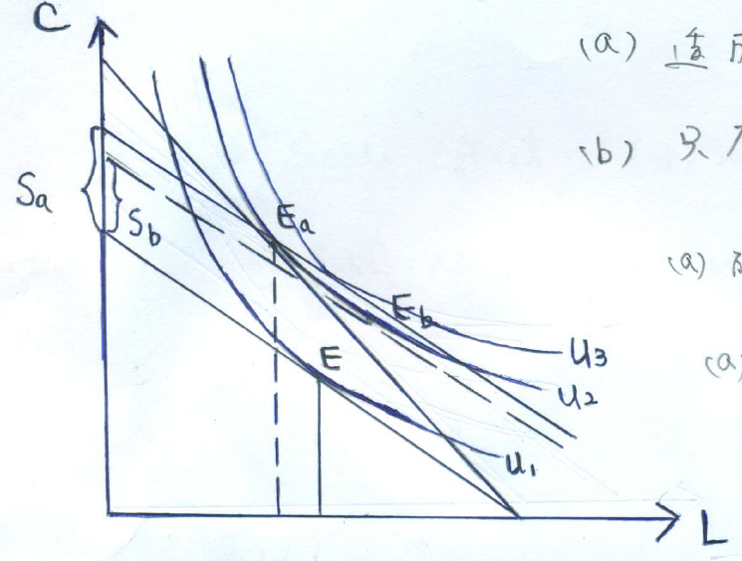
(a) 透過 S.E. 及 I.E.
(b) 只有I.E.
(a)的補助$S_{a}>S_{b}⟸$ (b)的補助
(a)有過度補償的效果，因為在$S_{b}$之下，可達到$u_{3}$的效用水準

- Suppose that indifference curves between consumption goods and leisure activities are concave to the origin. How many hours will a person allocate to leisure activities?
A worker will either work all available time or will not work at all. It all depends on the relative sloped of the indifference curves and budget line. As drawn, point B is preferred to point A, and the worker chooses not to enter the labor market.
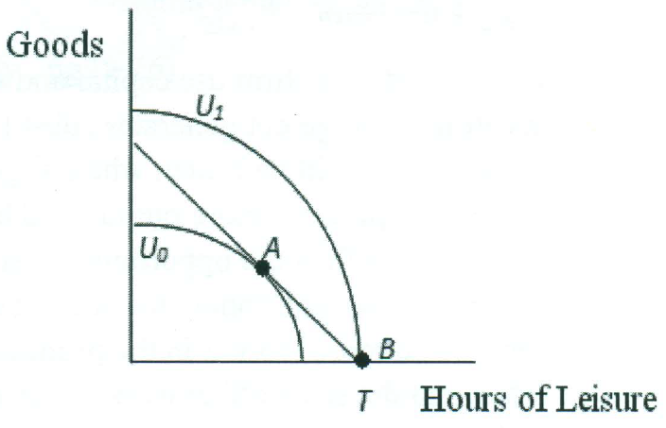
In this situation, point B is again preferred to point A, but the worker chooses not to consume any leisure and work all available time.
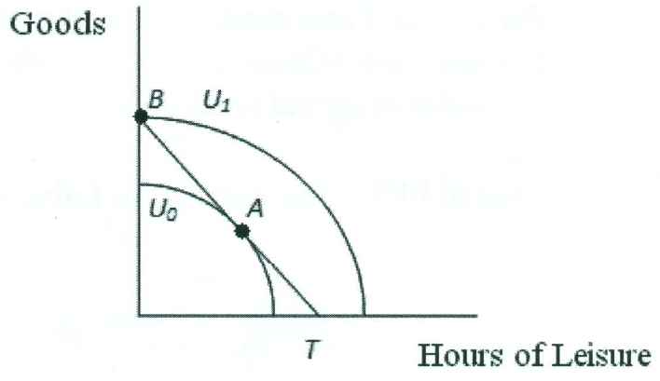

- What happens to the long-run demand curve for labor if the demand for the firm’s output increases? What happens to the long-run demand curve for labor if the price of capital increases? Decompose the changes into scale and substitution effects.
D↑$⟹π-Max. Q↑⟹Scale effect ⟹$ Iso- cost slope no change
$⟹$ E↑
r↑ $⟹\left\{\begin{aligned}Scale effect:E↓, k↓ \\ Subs. effect:E↑, k↓\end{aligned}\right. ⟹$E↑ iff $subs.e.>Scale$
$⟹$ E↓ iff $subs.e.<Scale$

